Write a program in C for minimum cost spanning tree

#include<stdio.h>

#include<conio.h>

int a,b,u,v,n,i,j,ne=1;

int visited[10]= {0}, min, mincost=0, cost[10][10];

void main() {

clrscr();

printf("\n Enter the number of nodes:");

scanf("%d",&n);

printf("\n Enter the adjacency matrix:\n");

for (i=1;i<=n;i++)

for (j=1;j<=n;j++) {

scanf("%d",&cost[i][j]);

if(cost[i][j]==0)

cost[i][j]=999;

}

visited[1]=1;

printf("\n");

while(ne<n) {

for (i=1,min=999;i<=n;i++)

for (j=1;j<=n;j++)

if(cost[i][j]<min)

if(visited[i]!=0) {

min=cost[i][j];

a=u=i;

b=v=j;

}

if(visited[u]==0 || visited[v]==0)

{

printf("\n Edge %d:(%d %d) cost:%d",ne++,a,b,min);

mincost+=min;

visited[b]=1;

}

cost[a][b]=cost[b][a]=999;

}

printf("\n Minimun cost=%d",mincost);

getch();

}

OUTPUT-

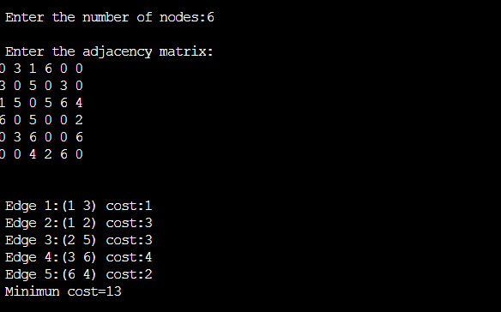s